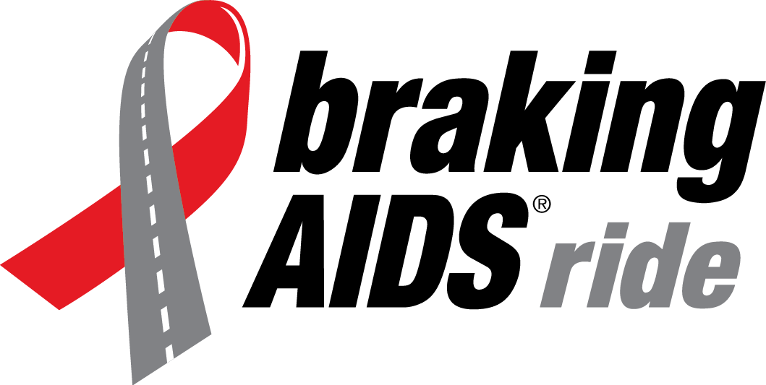
Cycling Apparel
Order Form

Name: _____________________

Please note that all orders must be prepaid by check or credit card by Friday, June 16. Size charts are available online.

Item | Men’s/ Women’s* | Size (Circle) | Cost, Each | Quantity | Your Cost
Sleeveless jersey | Men’s/Women’s  Fitted/Relaxed | XS S M L  XL 2XL 3XL | $67
Short-sleeve jersey | Men’s/Women’s  Fitted/Relaxed | XS S M L  XL 2XL 3XL | $68
Long-sleeve jersey | Men’s/Women’s  Fitted/Relaxed | XS S M L  XL 2XL 3XL | $78
Bib shorts | Men’s/Women’s | XS S M L  XL 2XL 3XL | $68
Cycling shorts | Men’s/Women’s | XS S M L  XL 2XL 3XL | $68
Water bottle |  |  | $10
Shipping** |  |  | $7
Total cost

* Jerseys are available in fitted or relaxed cuts. A detailed size chart is available online.

**If you are picking up your apparel from the Global Impact Productions office, at a pre-Ride event, or on Registration Eve in Boston, there is no shipping cost. Otherwise, add $7 for your order.

Personal Check. Make check or money order payable to Housing Works and staple to this form.

Credit Card. VISA MasterCard American Express Discover
Account Number _______________________________ Exp/Mo/Yr _______________
Security Code _______________ Signature ___________________________________

Please make check payable to Housing Works.

Mail this form with payment to:
BRAKING AIDS® Ride
127 West 26th Street, Suite 402
New York, NY 10001

Or fax with credit card payment to:
212.807.1853

